**Exp. 11 Changing hardware compatibility**

**Aim:**

To change Hardware compatibility of a VM (Either by clone/create new one) which is already created and configured, using virtual box.

**Procedure:**

* Open virtual box application
* Click on any VM you want to change hardware compatibility of.
* Click on settings, then System
* Make the required changes and click ok.
* Now the changes are made.

**Output:**

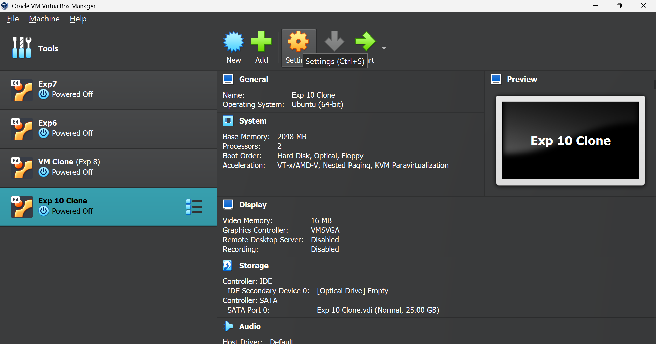

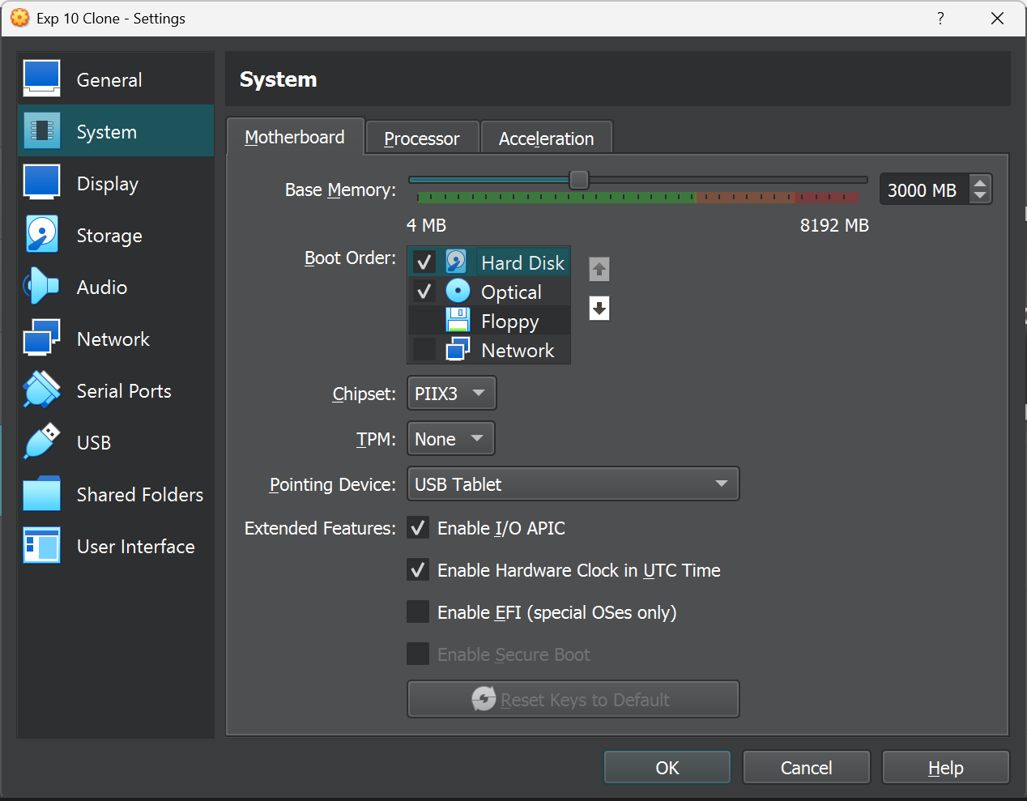

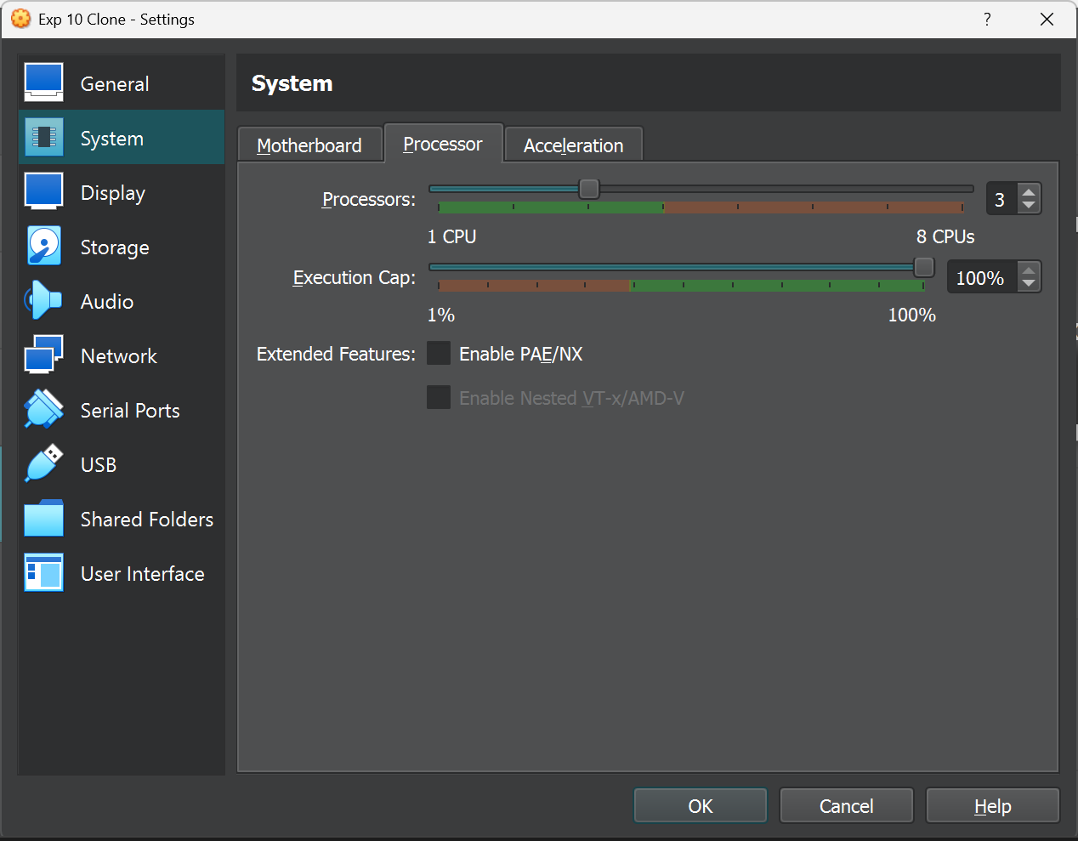

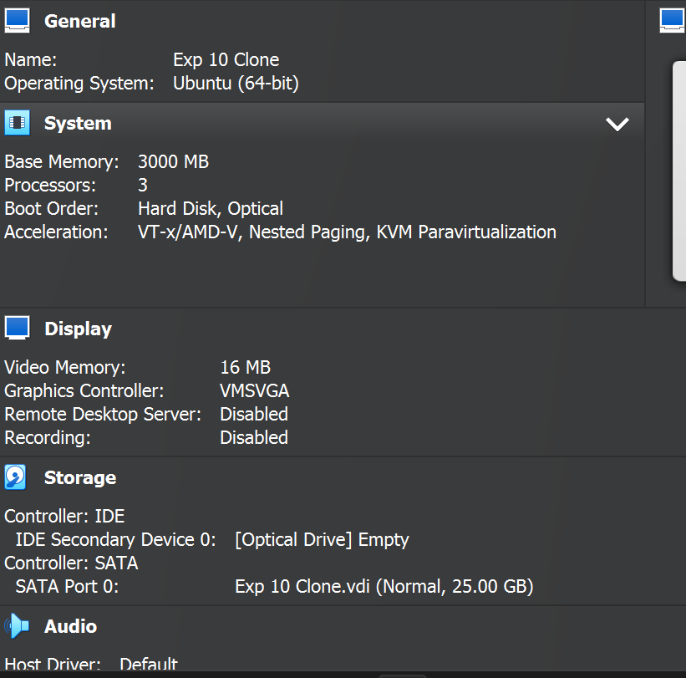

**Result:**

Thus the hardware capabilities of a VM was changed successfully